**Assignment 2**

**Submitted by**

**P.A.N.D.Panditharathna**

**IT19157306**

**Step 1 – Data Source**

When I created analysis services multidimensional and data mining project, I have used the data warehouse model (Olisi_DW), that I created in assignment one. At the below DW data source has been shown.

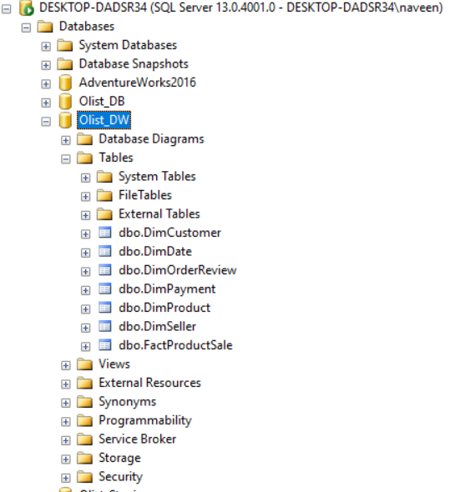

**Step 2 - SSAS Cube implementation**

1. First create data source - When creating the multidimensional model, at the beginning I had configure data source (Olist_DW).

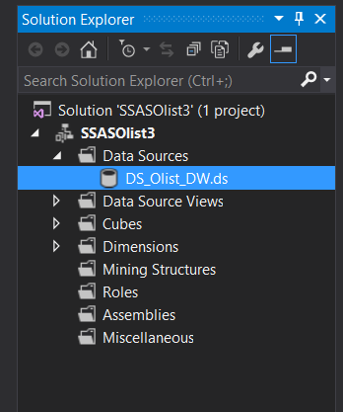

1. 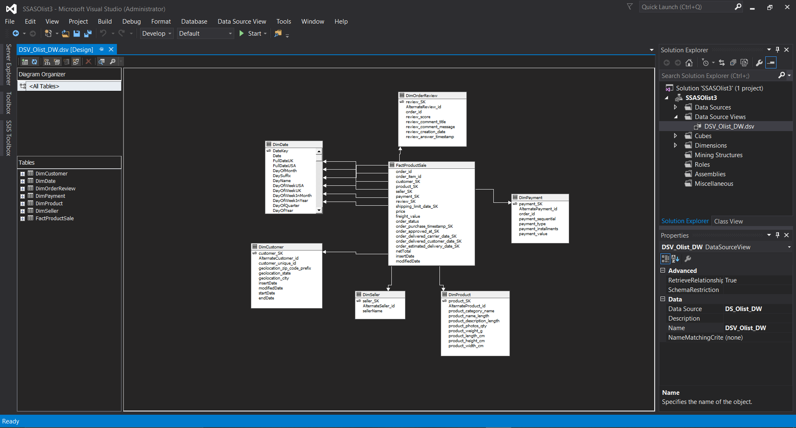Next create data source view - After that I was creating data source view. There it has automatically selected and added the related dimension tables to fact table that I selected.
2. 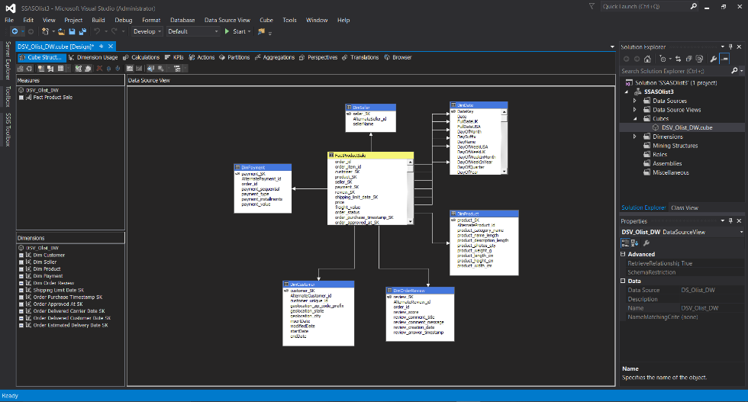Creating a cube – Now I have created data source view including the tables that I needed to create the cubes. So here, I have used the existing data source to create the cubes.

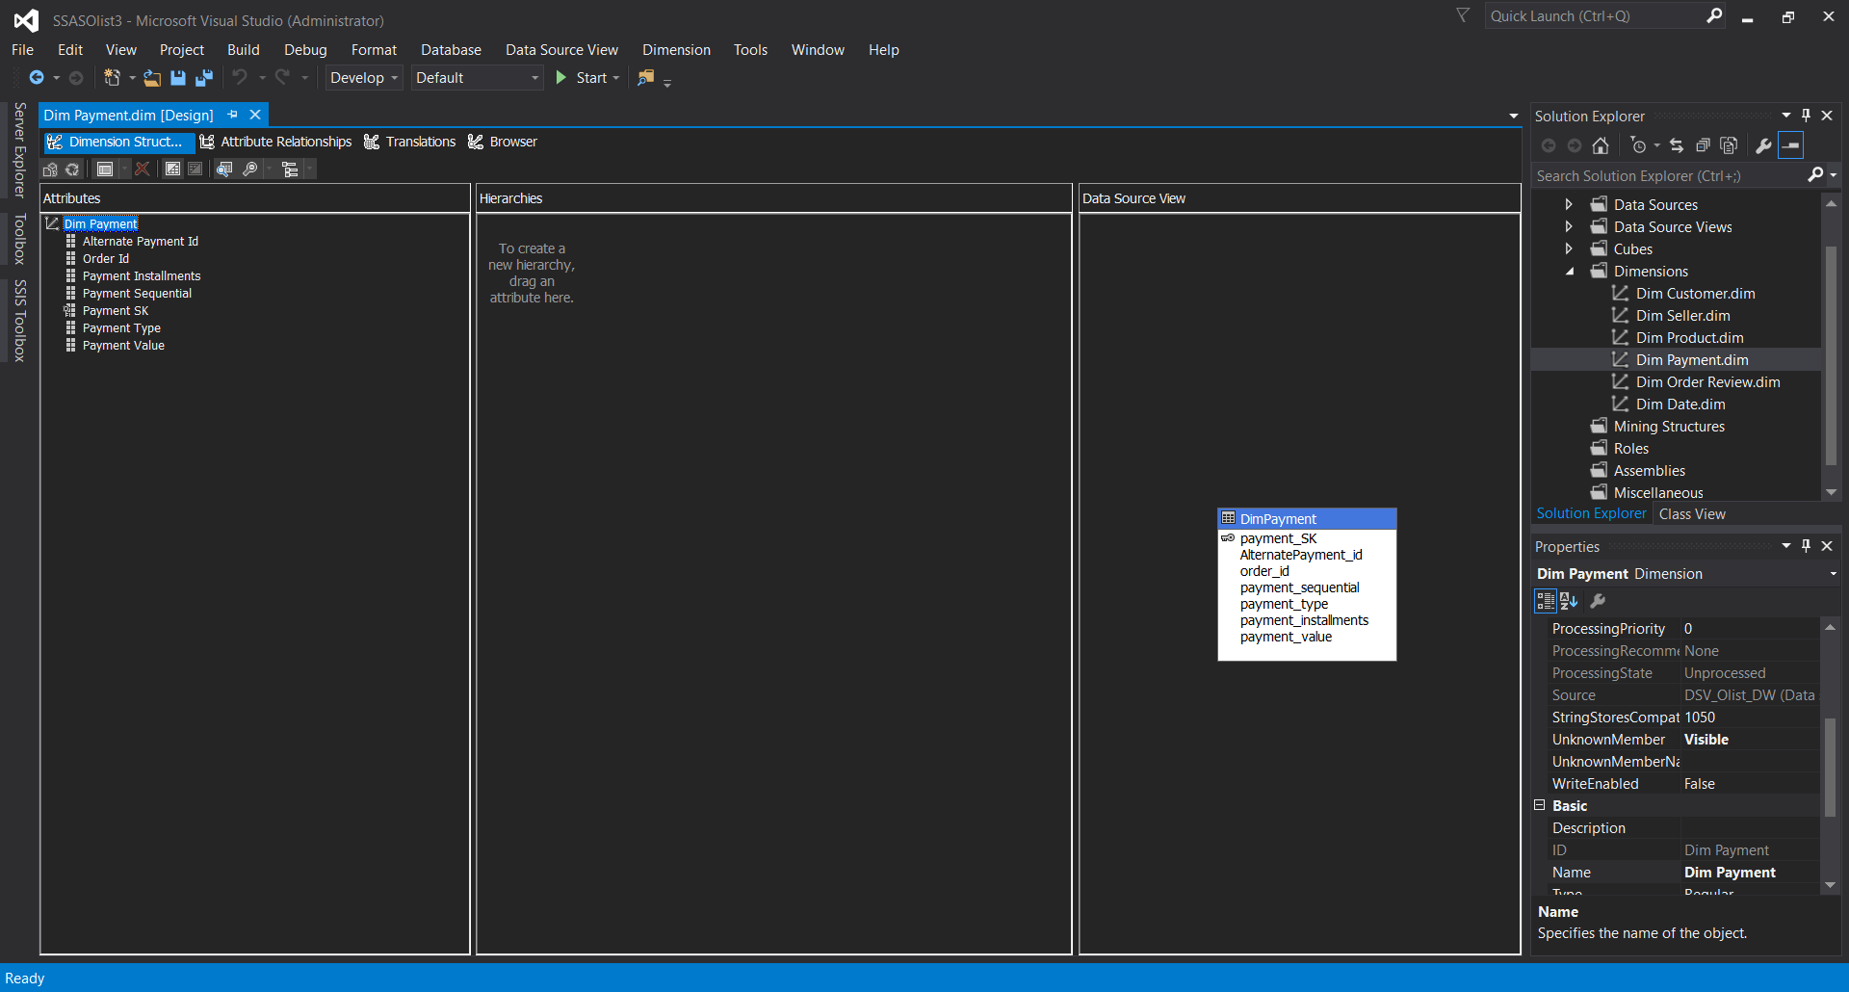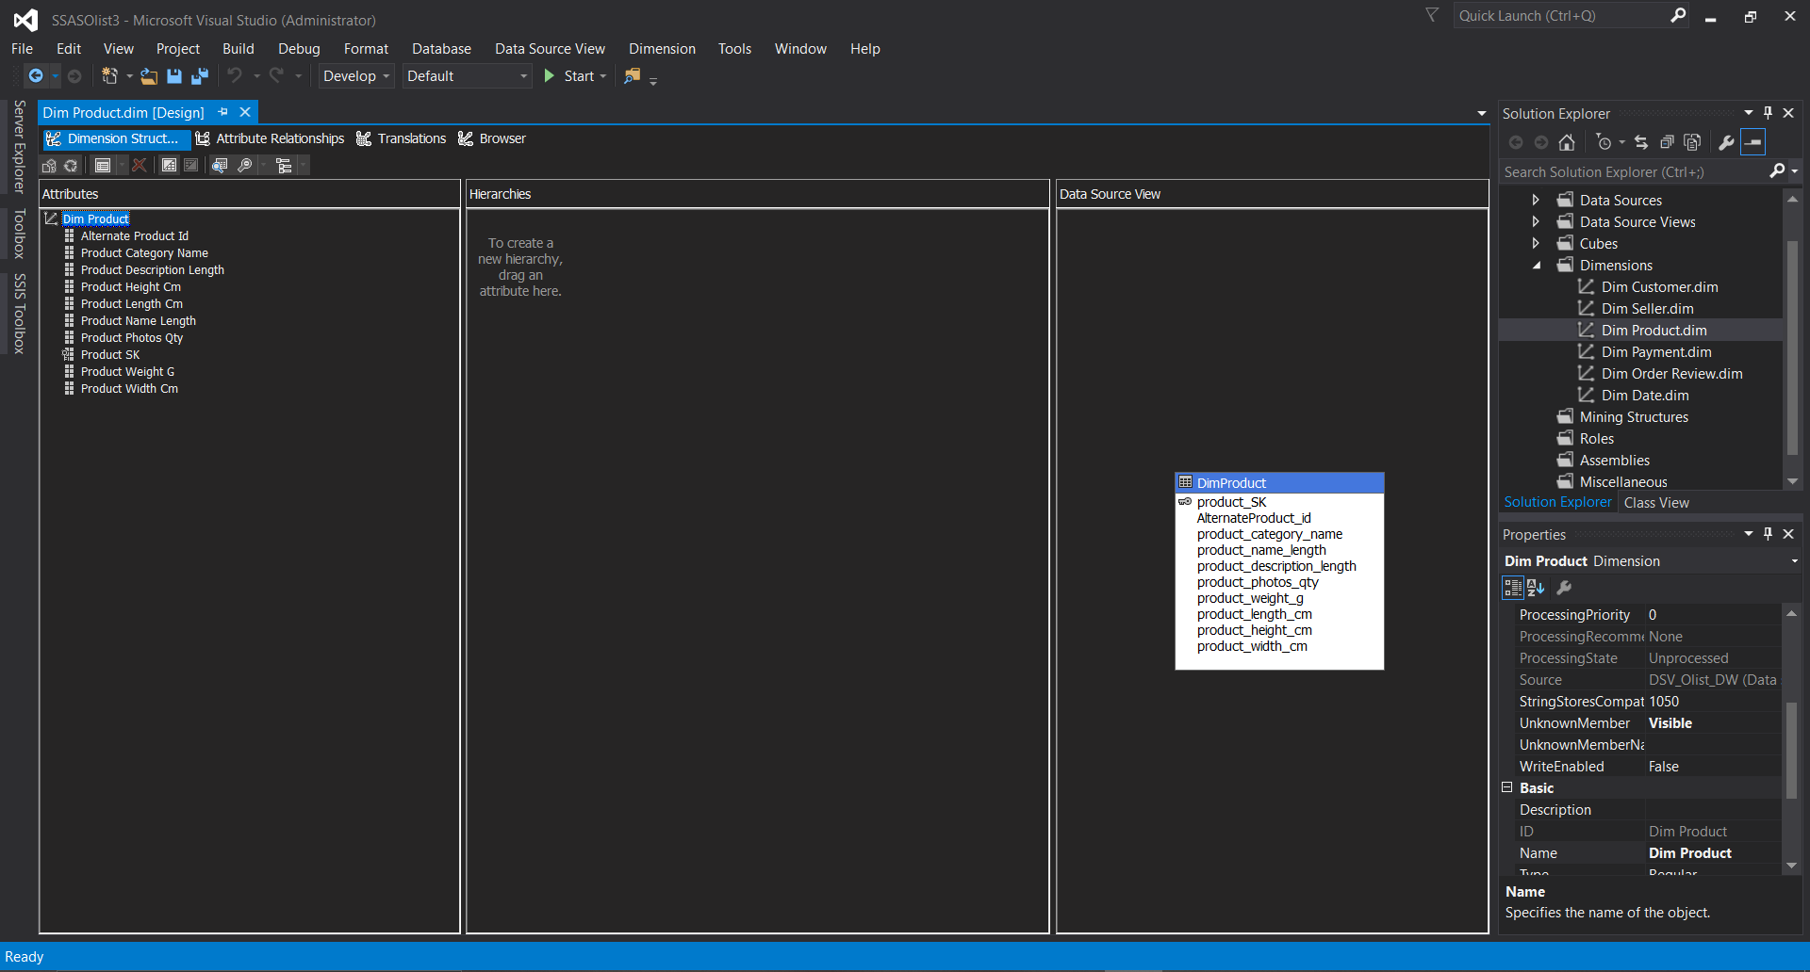Then I had to configure all the dimensions to list all attributes as show in below.

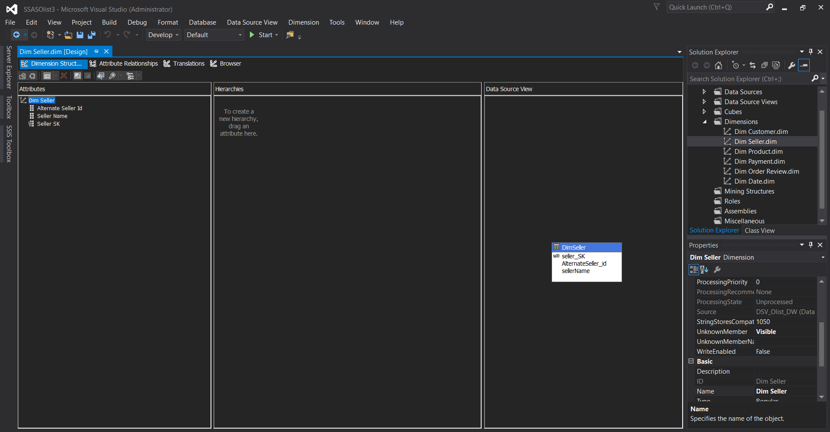

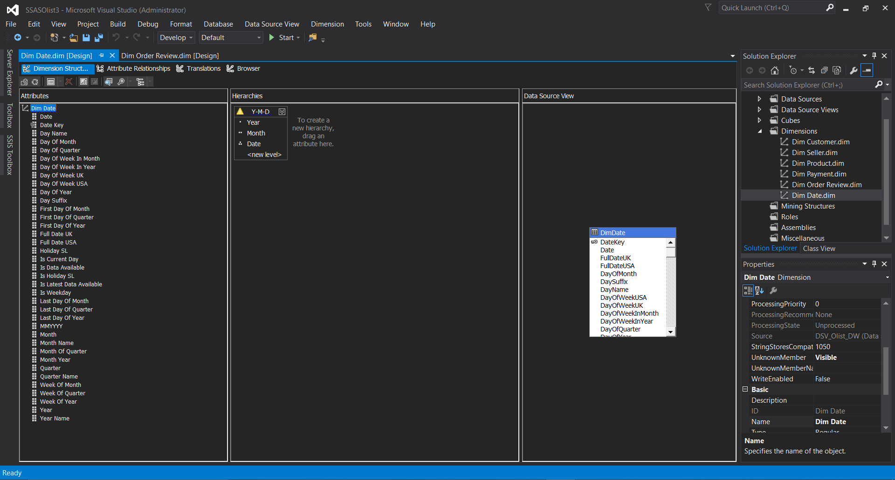

Implementing hierarchies to DimDate

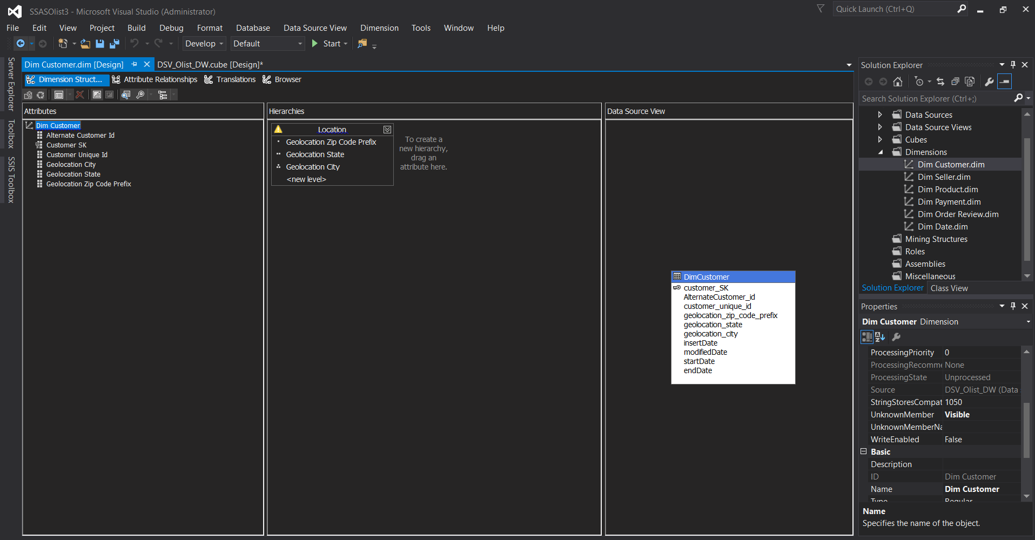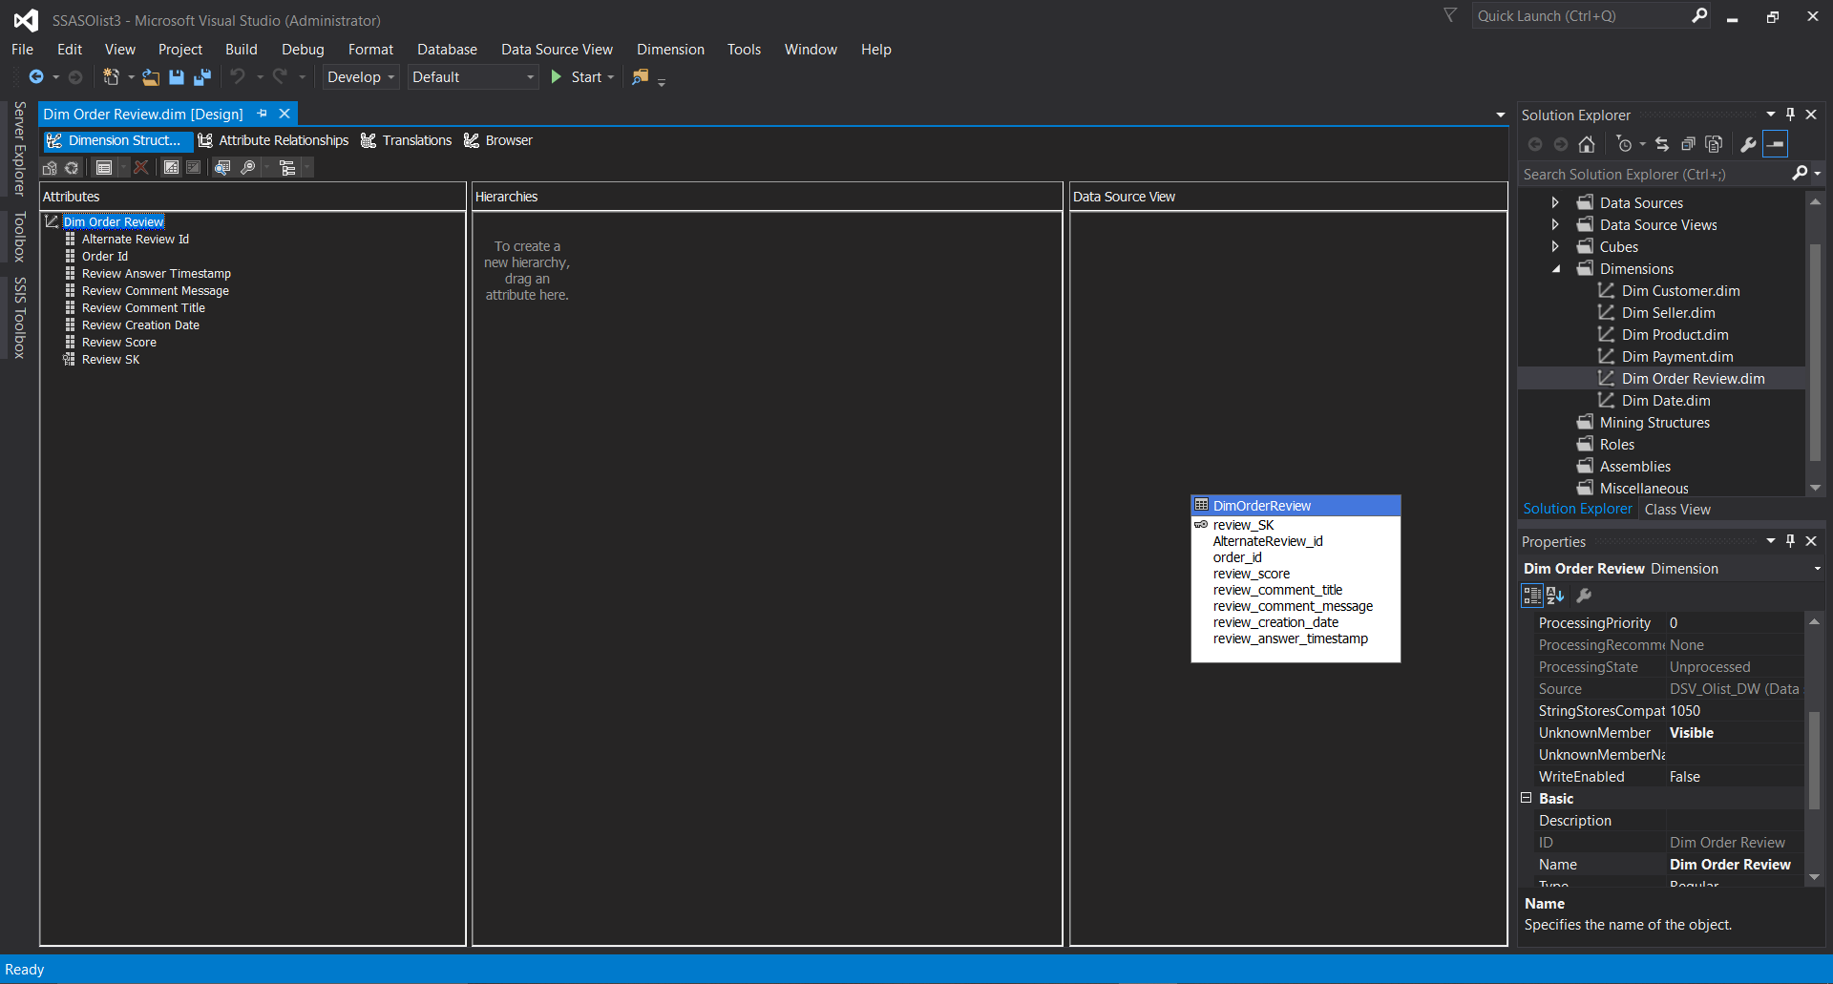

Implementing hierarchies to DimCustomer

1. Deploy the cube – There were some deployment errors, when I was running the process. I tried to solve the error. First, I built the project and click process button. Then I saw the error in some dimensions those have null values. In that case I go the table properties and changed allow to null values.

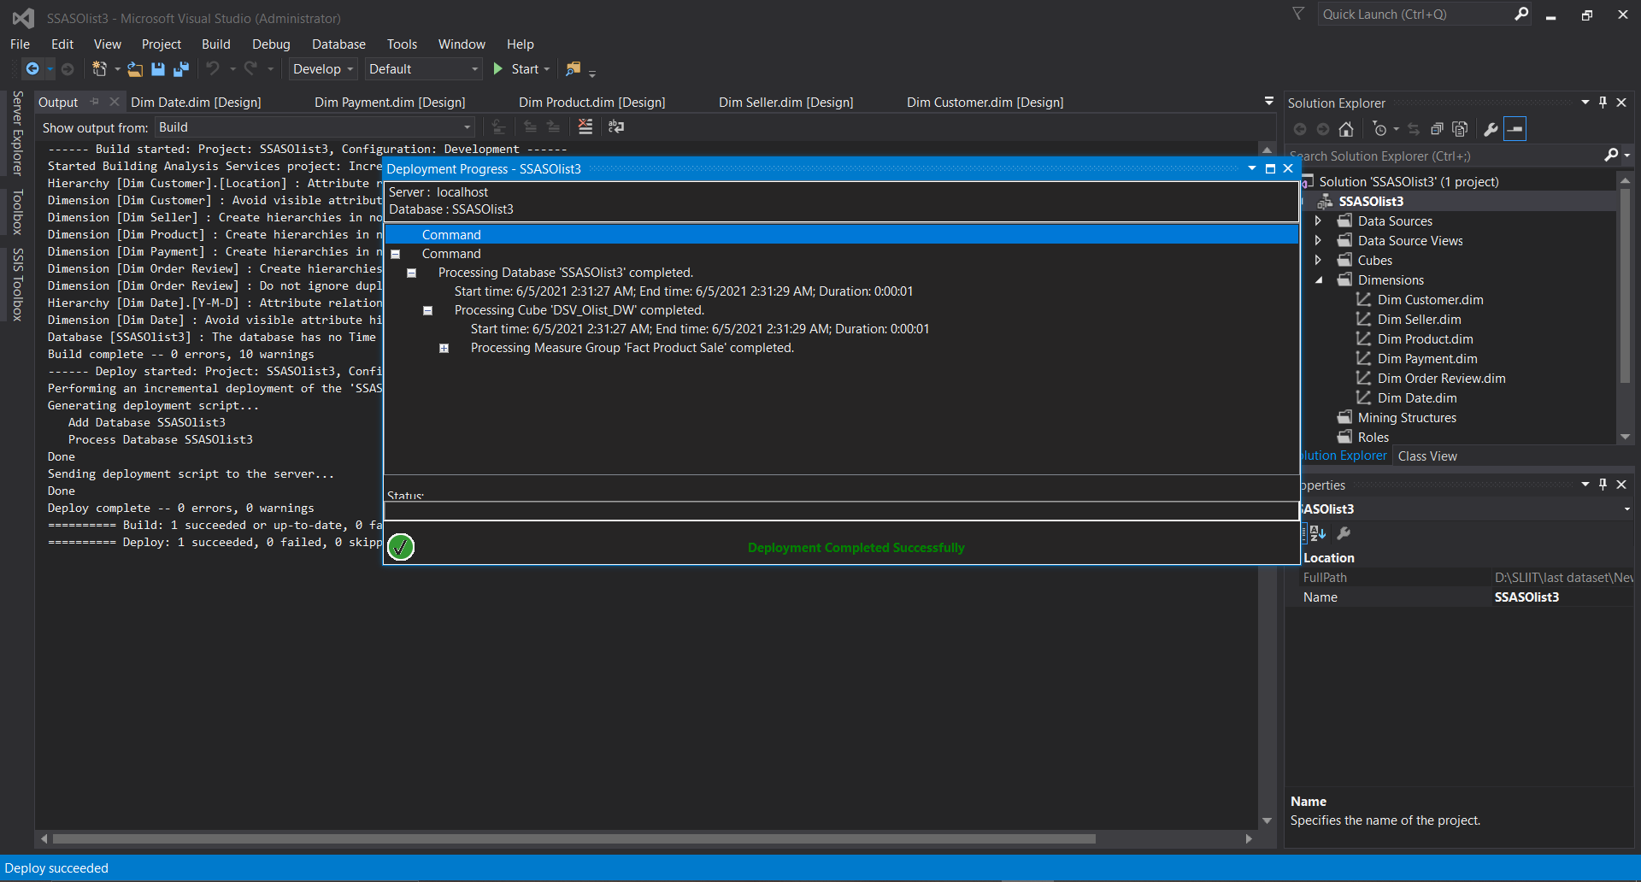

1. 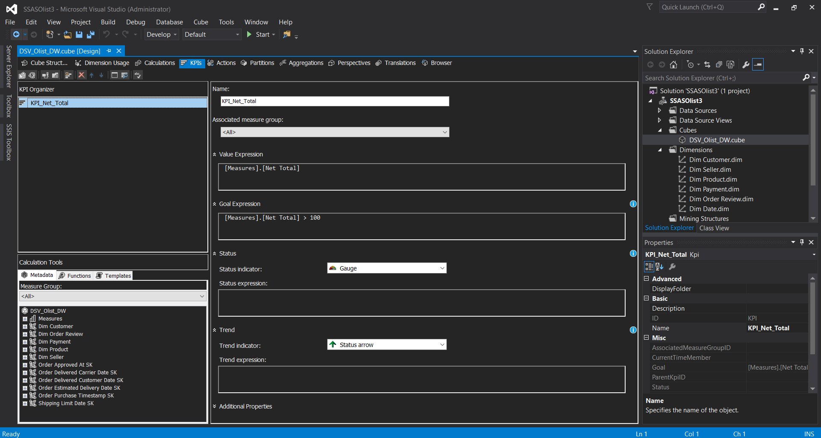Create KPI – after deploying the cubes, I started to create KPI. I have created one KPI as the blow shown.
2. 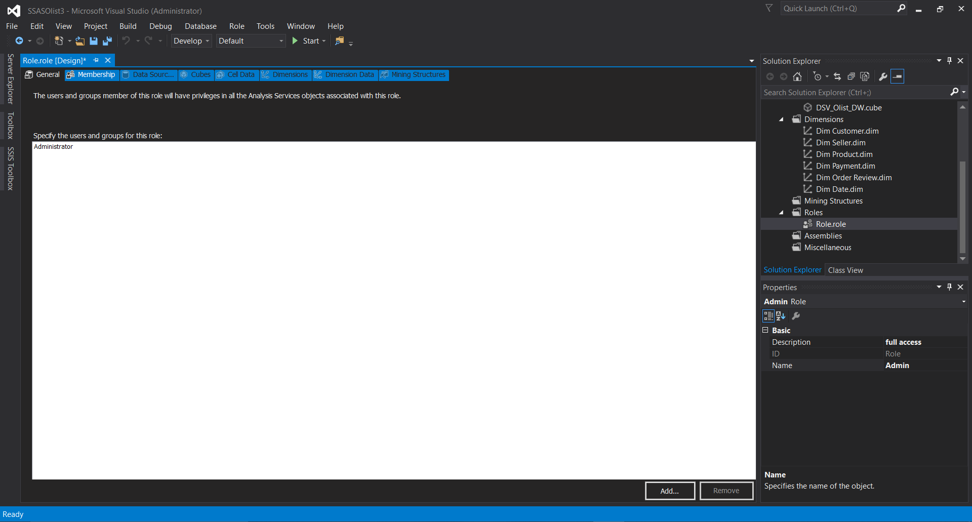Create a role – user roles are created to provide permissions on who has access to the data cubes
3. Browse cube data – done all the necessary things and deploy cube, then go to browse tab

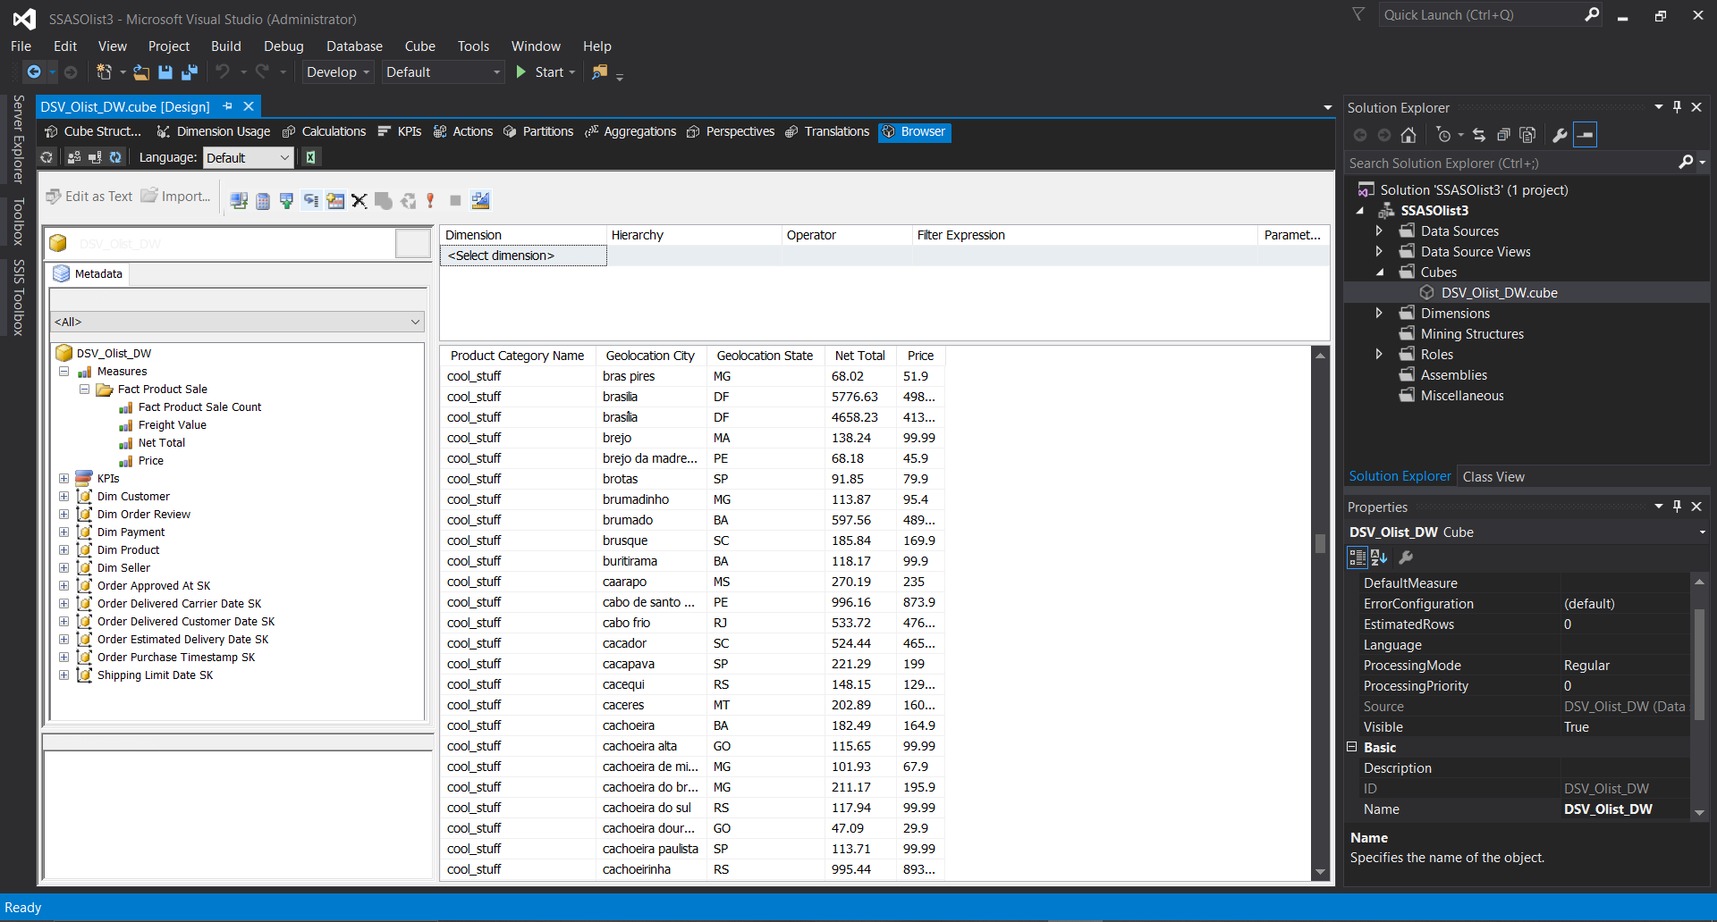

After all these steps are done successfully, data has loaded into the cube inside the SQL server management studio and multidimensional project has been created successfully.

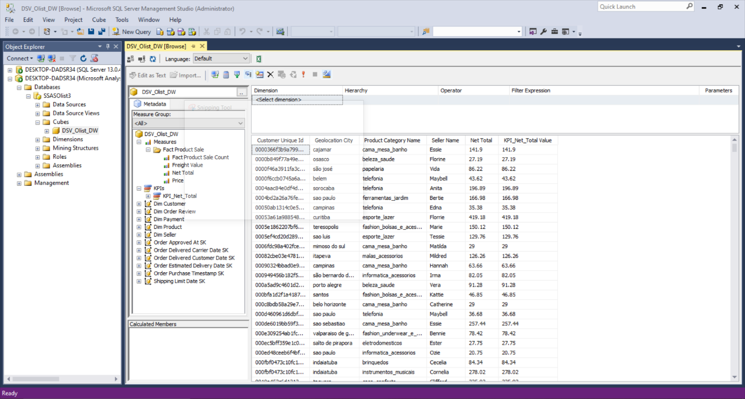

**Step 3: Demonstration of OLAP operations**

Now I have created the data cube, then I had to create a report in Microsoft excel using the data in the cube. To access data in the cube that I created, I used MDX queries. There is a simple way to generate MDX query. I have shown them at the below.

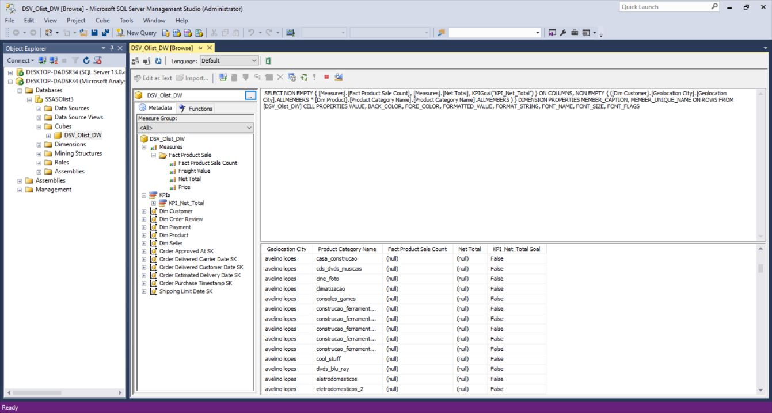

I have used this query in excel sheet to generate a report through Excel.

**Loading data into the excel sheet using power pivot**

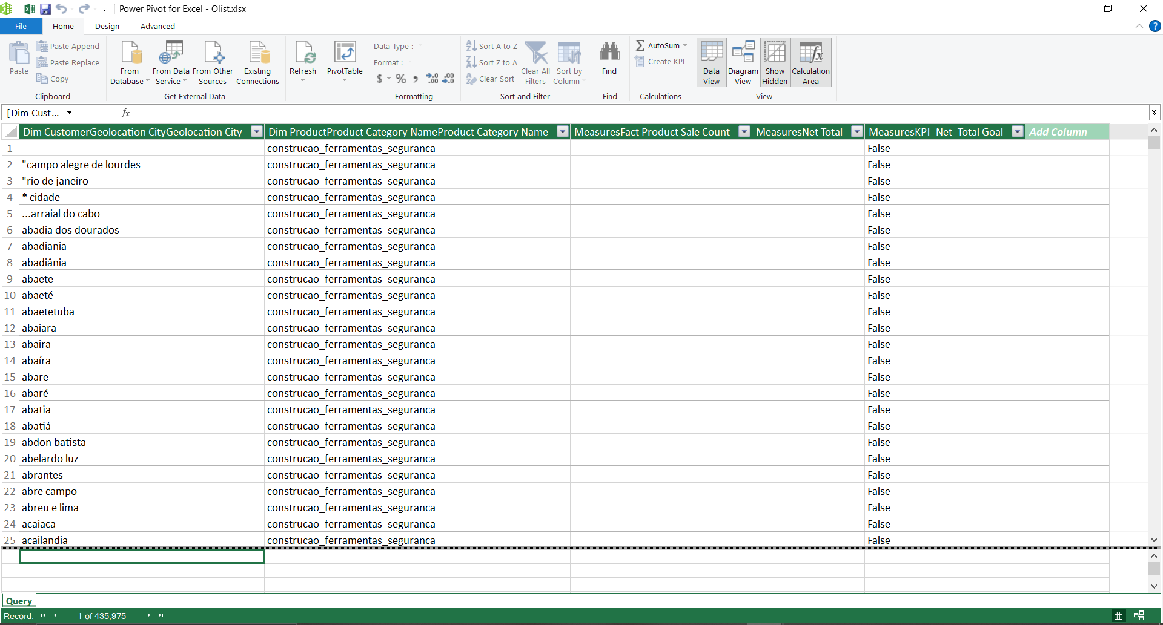Connecting excel to SSAS cube using MDX query using power pivot.

**OLAP Operations**

1. Pivot

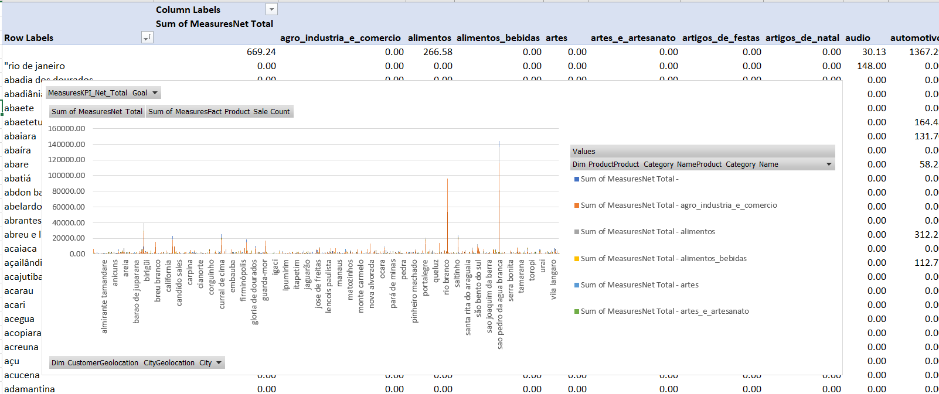

1. Slicer

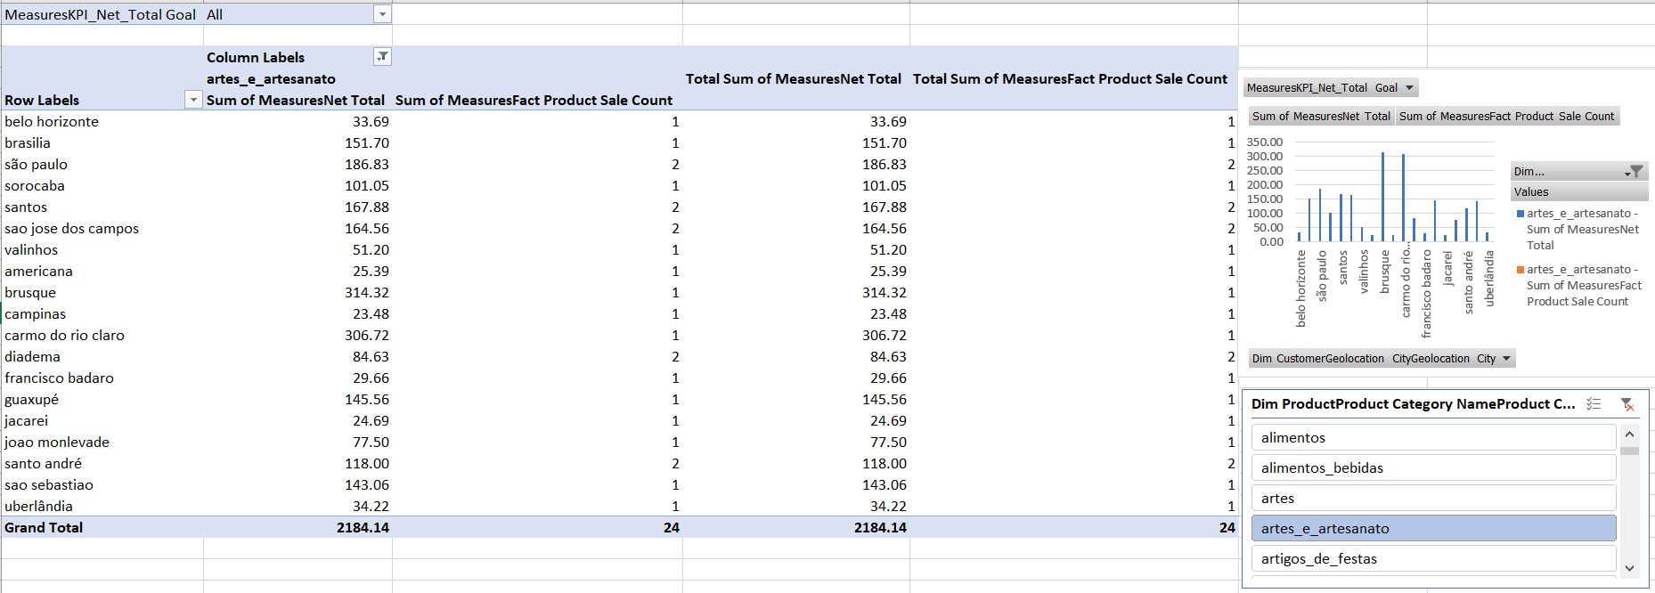

1. Dice

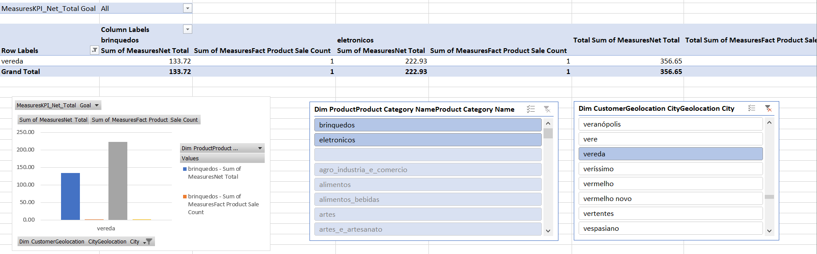

1. Roll up

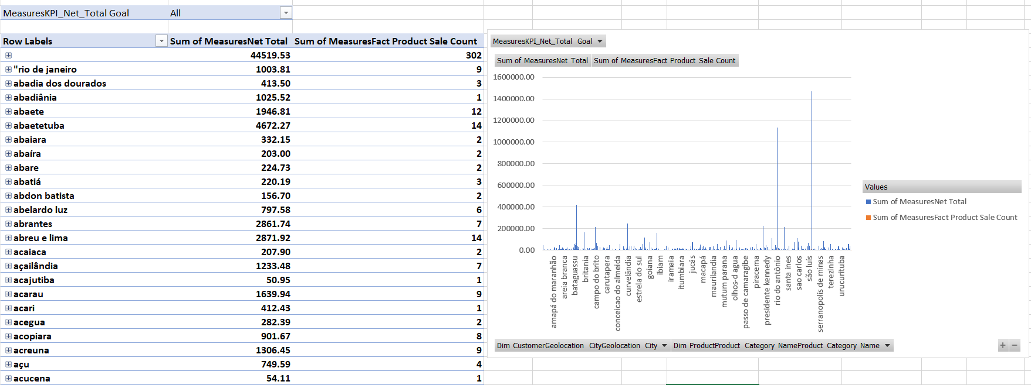

1. Drill down

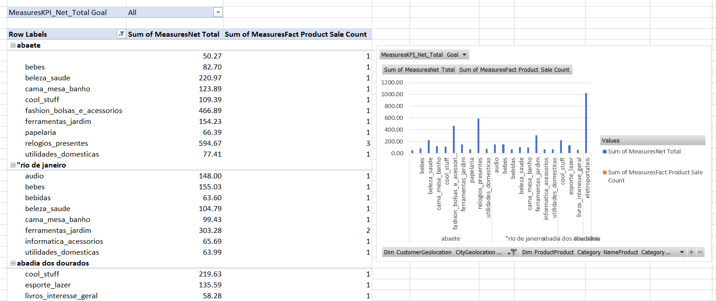

**Step 4: SSRS Reports**

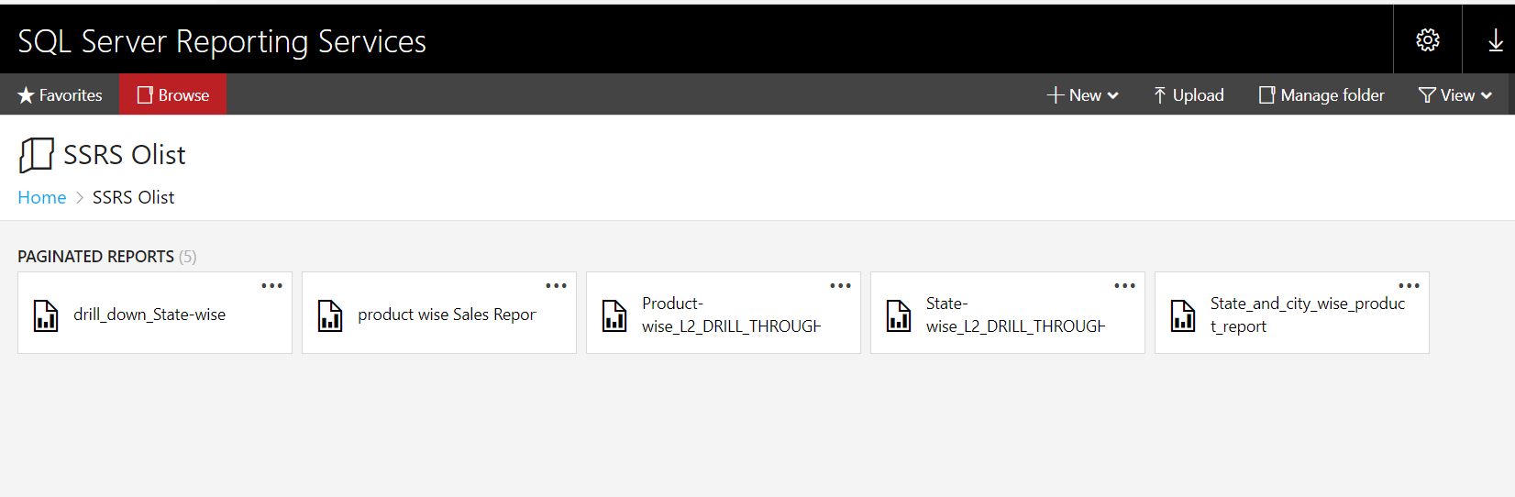

As the first step in here, I had to open the ‘Report builder’ and created a new project.

* Report 1 - Report with a matrix

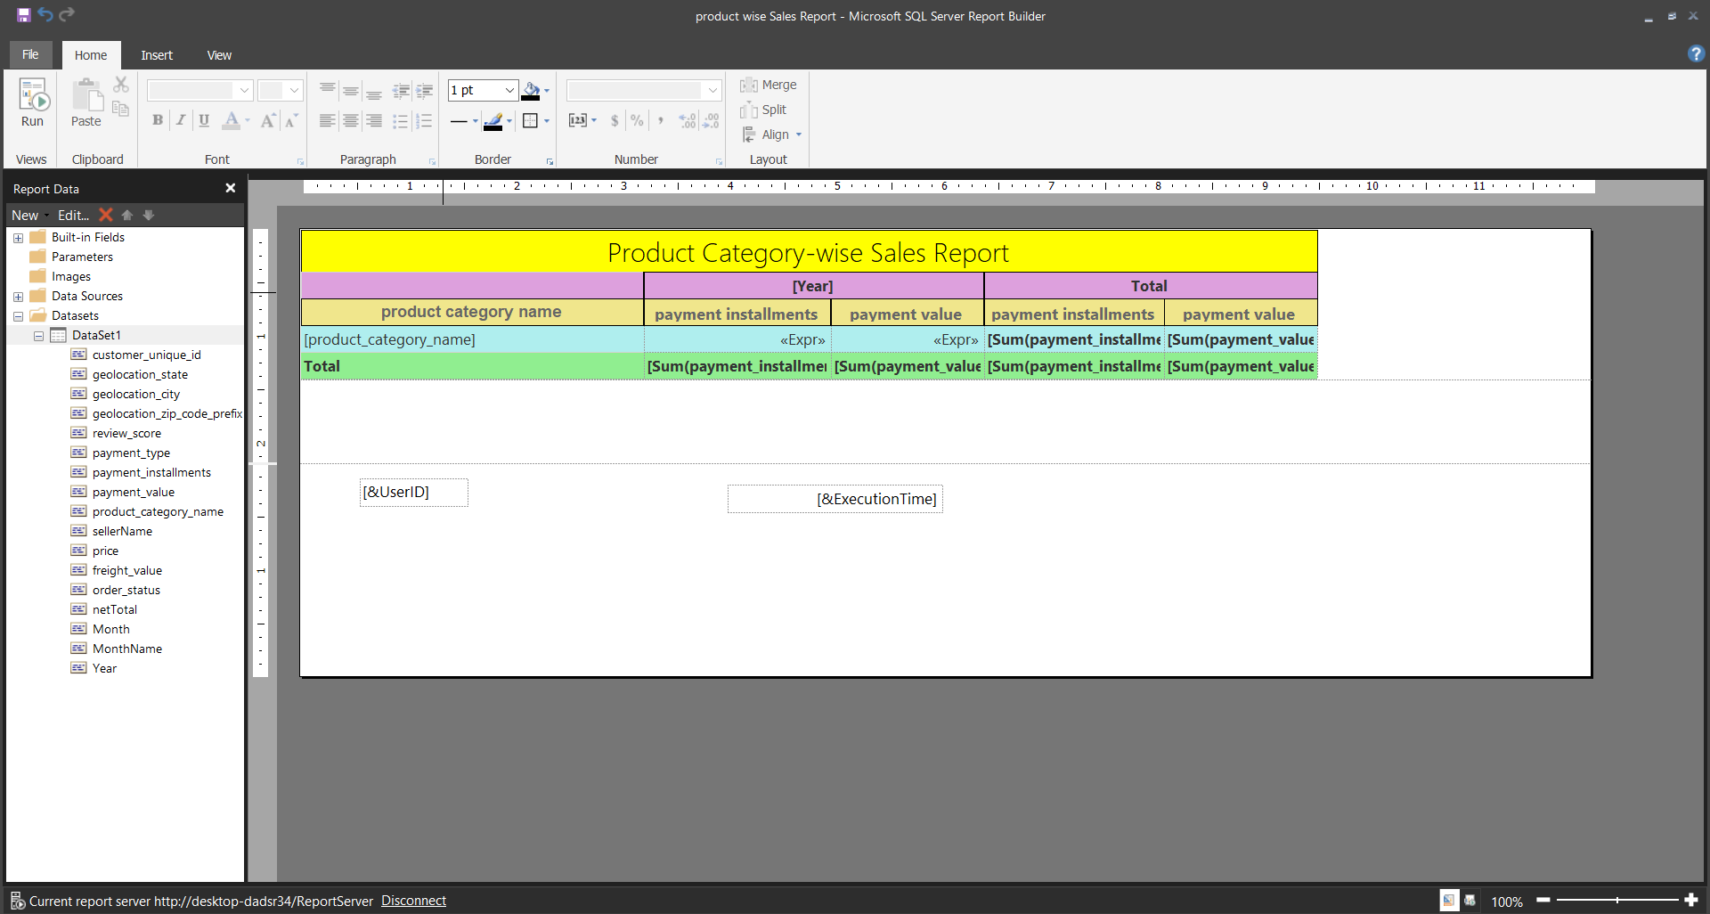

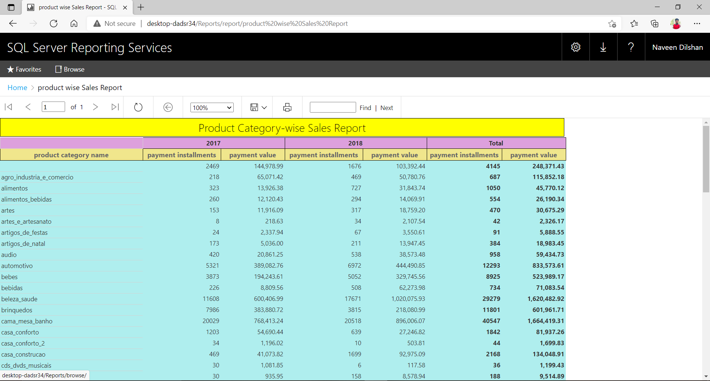

Report 2 - Report with two parameters, parameters have list of values and Selection of the value of first parameter changed the list of available values in the second parameter.

* 1. 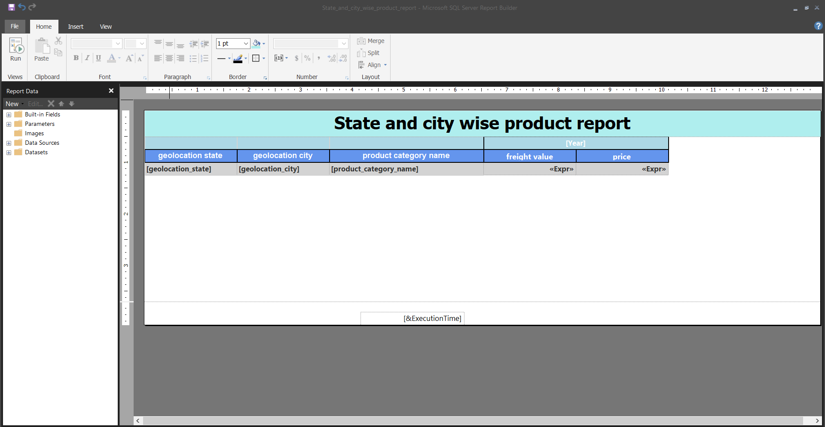

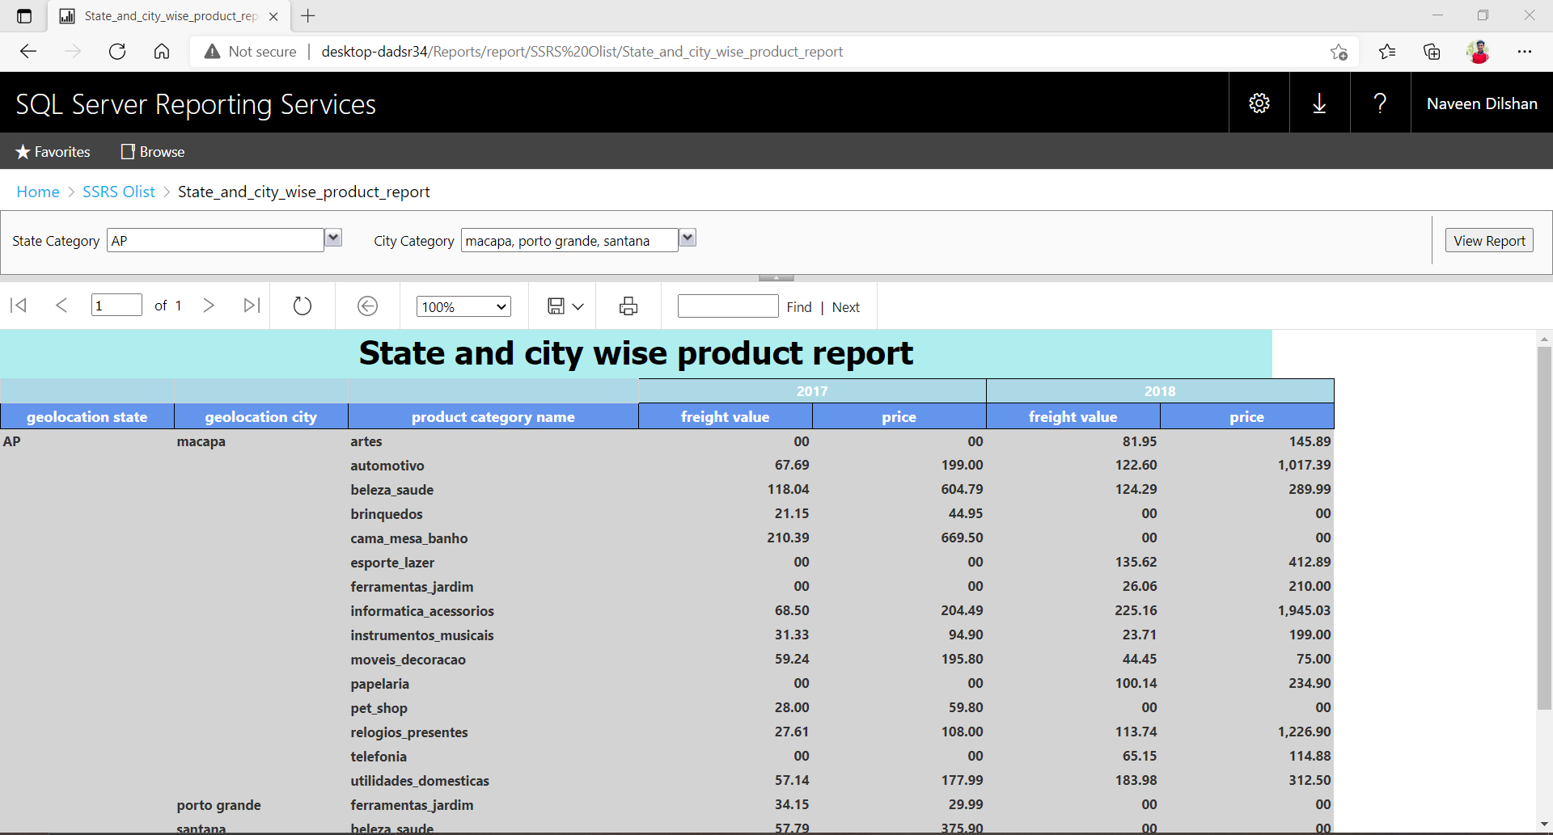

* 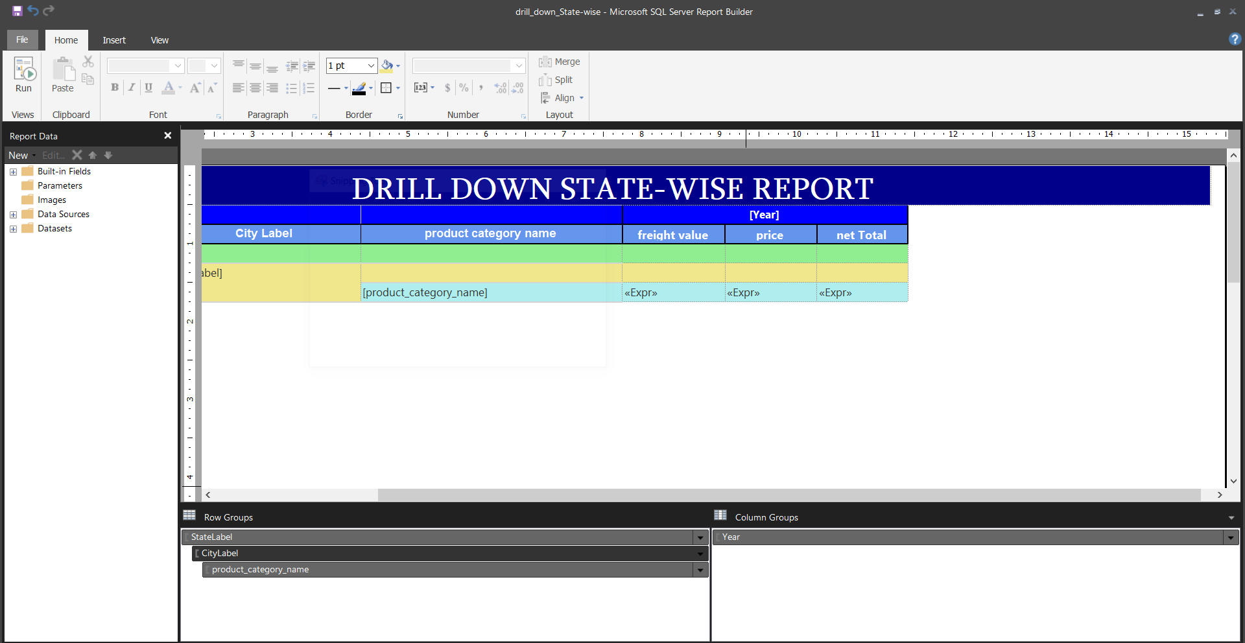Report 3 - Create an SSRS drill-down report

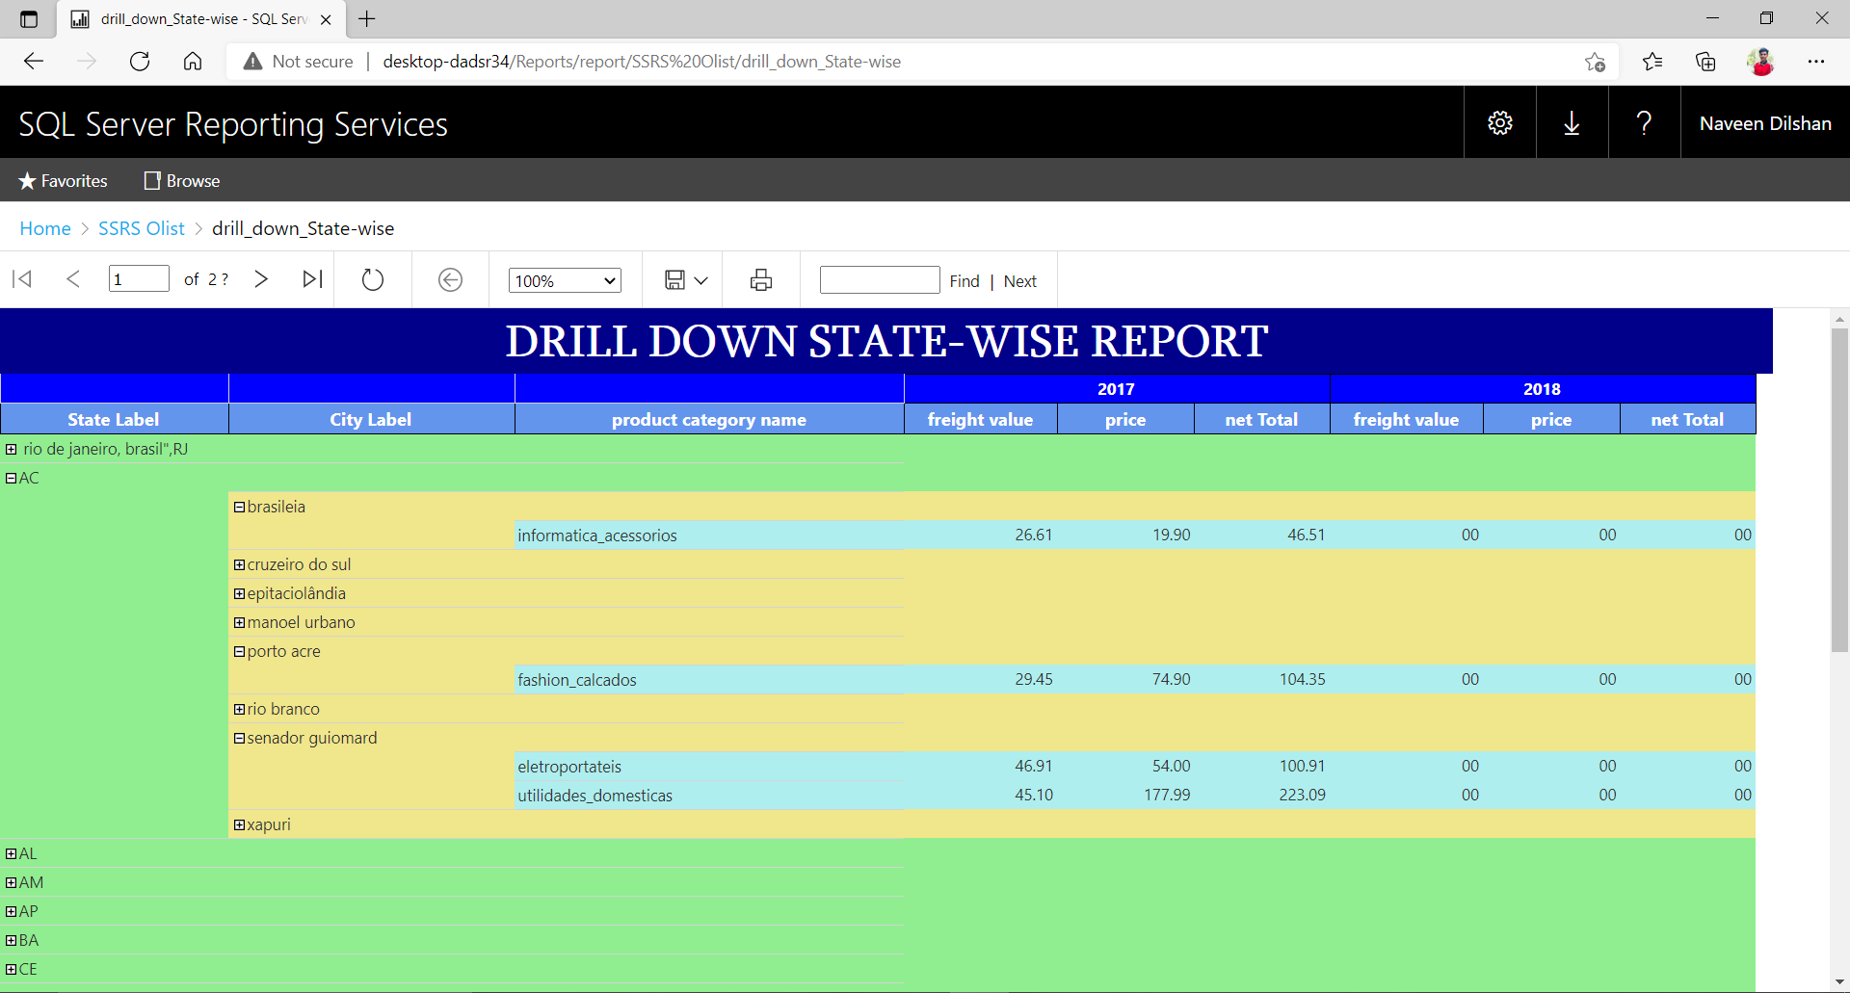

* Report 4 - Create an SSRS drill-through report

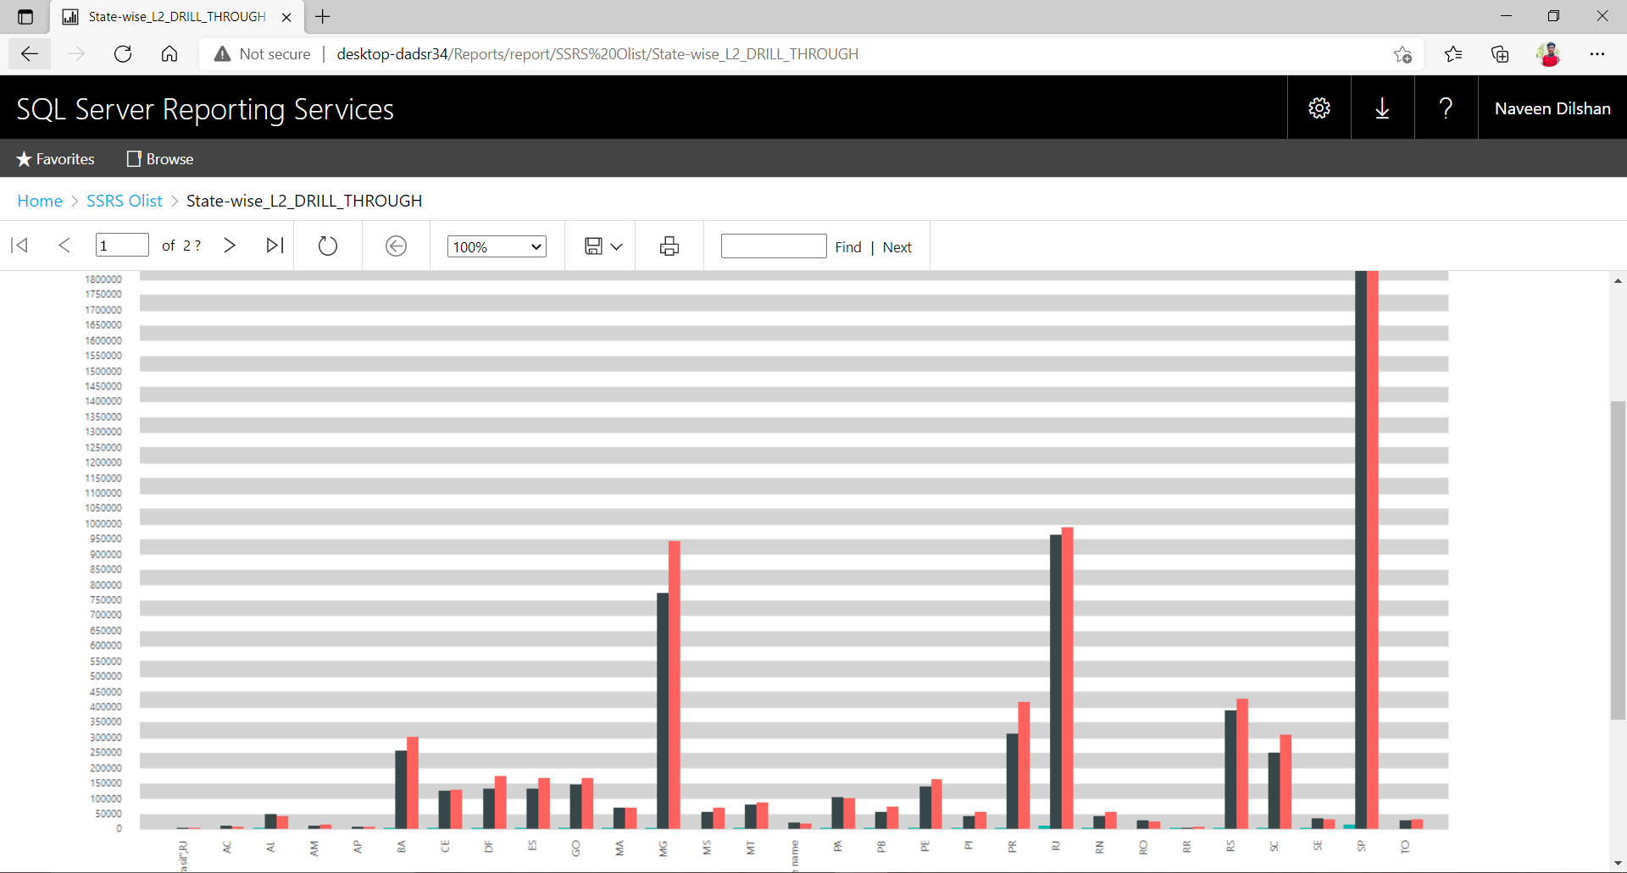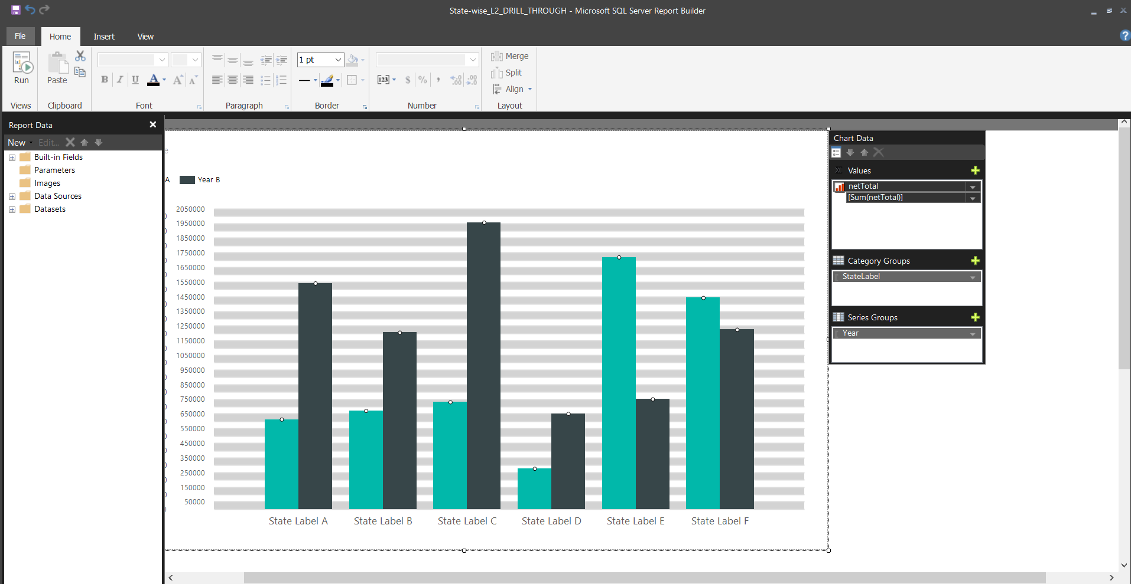(Report 1) – State Wise Chart – we can click any of the State column in chart it navigates to product chart

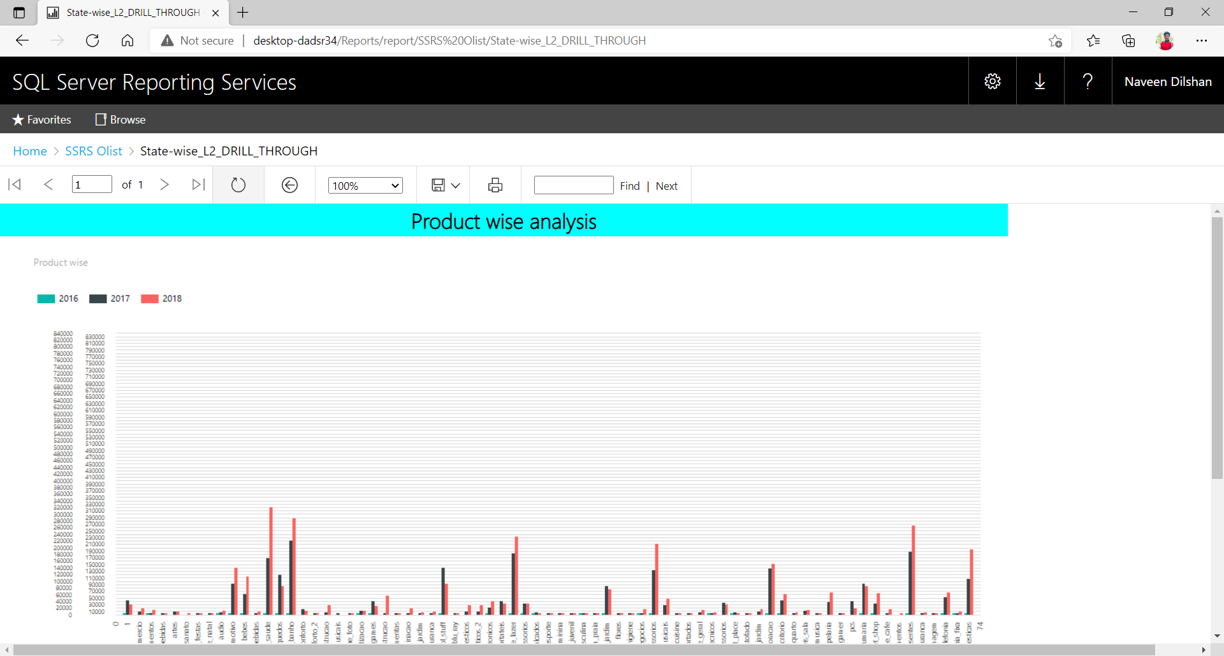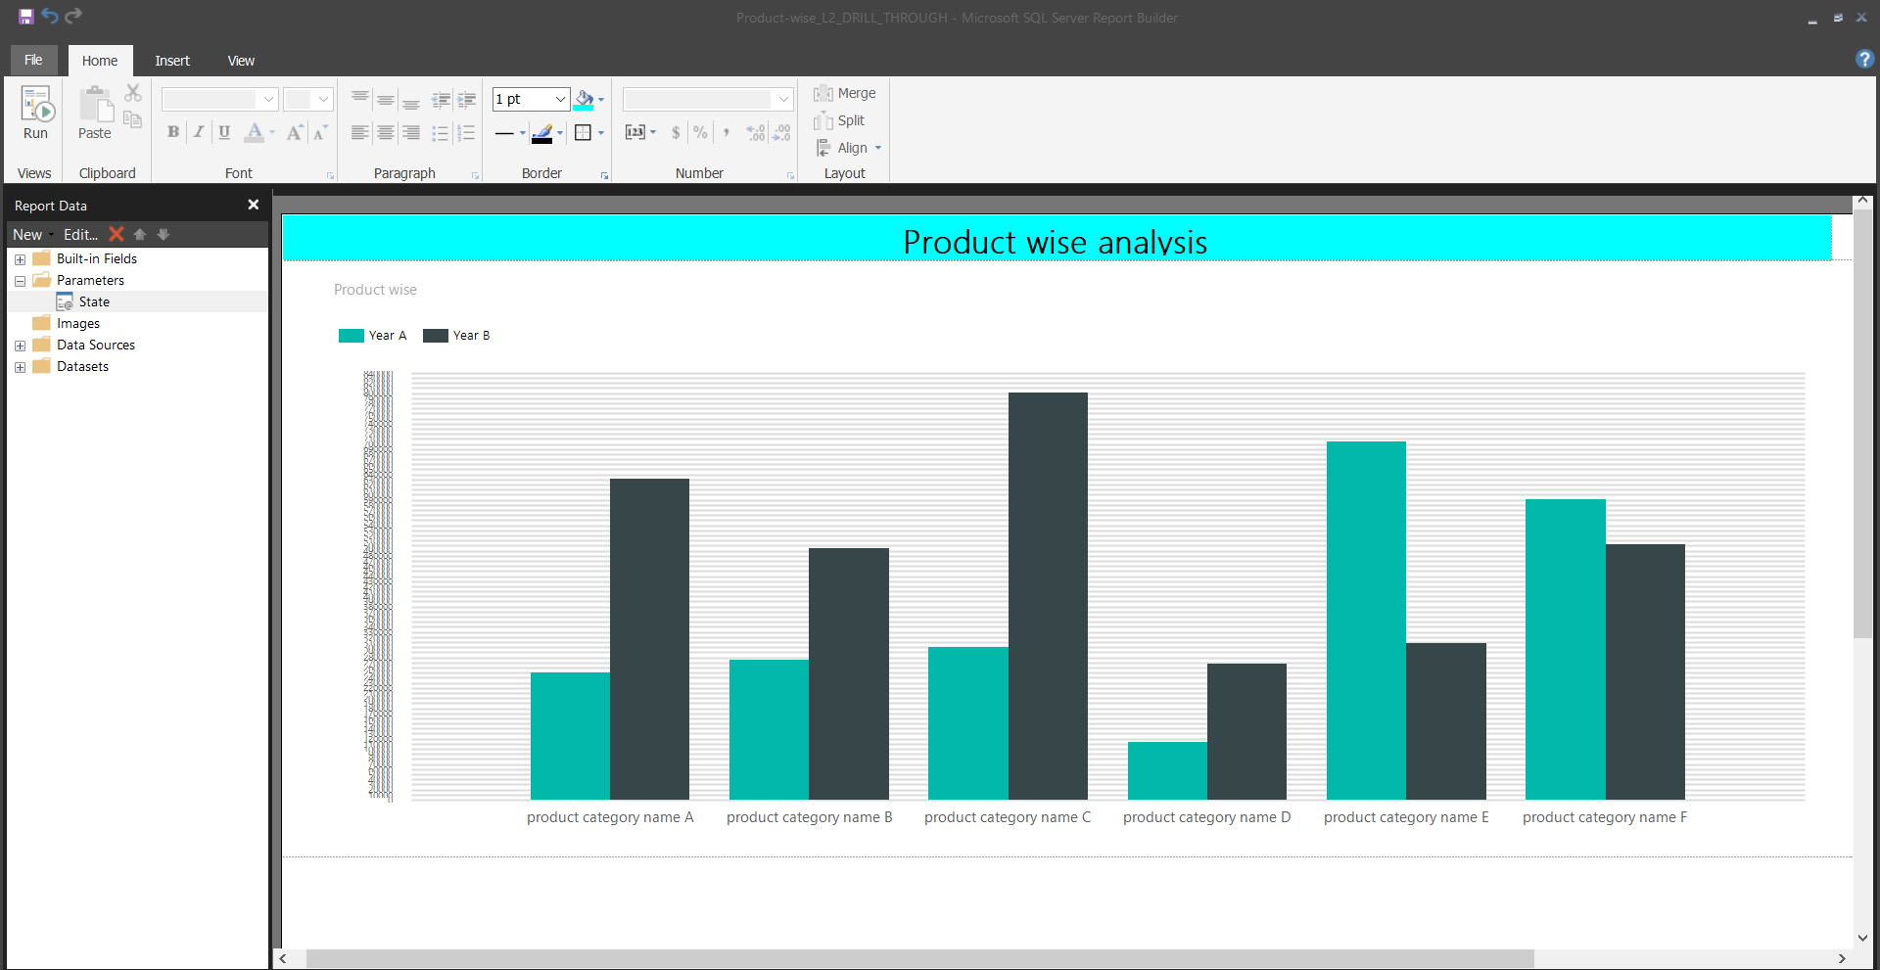(Report 2) – Product wise Chart- we can see products related to the state.

**Dashboard using power BI**

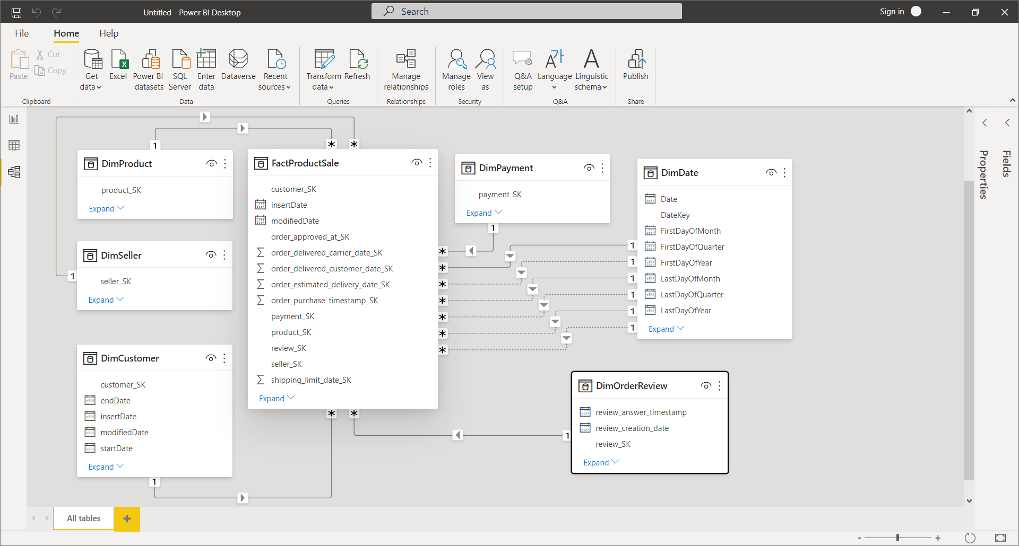**Model: -**

